SPEAKER / AUTHOR MEDIA KIT
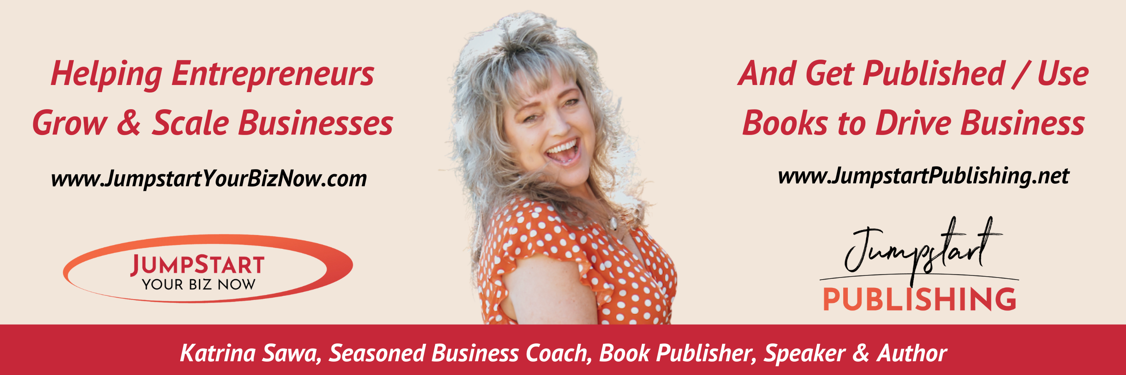

Hello and Thank You for taking the time to consider Katrina Sawa to be one of your featured speakers at your upcoming event, conference, webinar, radio show or podcast!

This document contains all the information you will need to make the decision to book Katrina Sawa to speak at your event as well as find everything you need to promote and market her talk including bios, talk descriptions, logo, headshots, interview questions, social links, references and more.

There are many videos of Katrina online, some of large presentations, some small and some quick video tips so you can get a sampling of her candor. For videos, go to www.JumpstartYourBizNow.com/speaking or www.youtube.com/c/KatrinaSawa

Katrina can sell or not sell from the stage as host prefers however we always ask that at minimum we can hold a drawing and/or have a display table in the room during the entire event as well to offer books and free stuff (virtual too). We are open to discussing opportunities for offering a commission to the event coordinator for anything we do sell; please let us know if you are interested in this or if you have the budget to purchase books for all your attendees to walk away with. We also typically promote your event to our email list and social following for more reach.


Thank you, we look forward to working with you!

Claudia Chicote

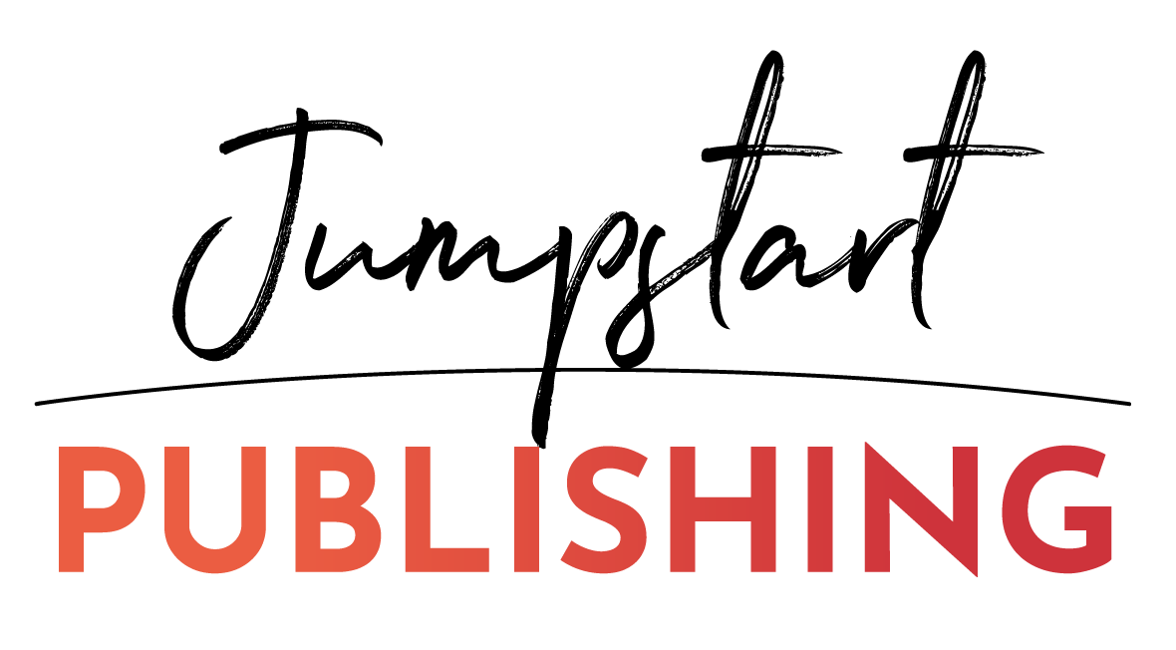
Katrina Sawa’s Online Business Manager
Please contact me with any questions or concerns:
(916) 872-4000
info@jumpstartyourbiznow.com

Why Choose Kat as a speaker for your event?

Katrina always gives, high-content, high-value presentations that are energetic, motivating and fun for all audiences. In Katrina Sawa’s presentations she usually always interacts with the audience, asking questions, getting them to think outside their comfort zone and to take notes on material she covers. She’s also been known to ‘spot coach’ some attendees during her presentations.

Please List Katrina as: Katrina Sawa, 15x Int’l Best-Selling Author with 23 books, Jumpstart Your Biz Coach, and Founder and CEO of JumpstartYourBizNow.com and JumpstartPublishing.net

Speaker Headshots and Social Links


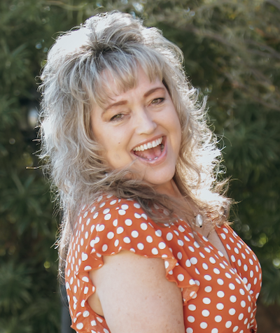

Main headshot link: https://jumpstartyourbiznow.com/wp-content/uploads/2022/07/KatrinaSawa-LeopardHeadshot.png

Contact links for Katrina Sawa online:

Business Coaching website: https://www.JumpstartYourBizNow.com
Book Publishing website: https://JumpstartPublishing.net
Speaker Webpage: https://www.JumpstartYourBizNow.com/speaking

Social Media Links:
https://www.facebook.com/katrinasawa/
https://www.facebook.com/JumpStartYourBizNow/
https://www.facebook.com/groups/JumpstartYourBiz
https://www.facebook.com/groups/TheAuthorSuccessCollective
https://www.YouTube.com/KatrinaSawa
https://www.linkedin.com/in/katrinasawa/
https://www.instagram.com/katrinasawa/

Katrina Sawa Short Bio

Katrina Sawa is a sought-after business coach, international speaker, and book publisher. Known for her direct, humorous and inspiring style, Katrina delivers actionable insights that leave audiences equipped and motivated to take their businesses to the next level. With 25 years of experience, she has helped thousands of business owners level up their confidence and pricing, simplify their marketing, automate operations, and build sustainable revenue streams. As the founder of Jumpstart Publishing, Katrina has also guided over 230 entrepreneurs through the process of becoming a published author, using books as powerful tools to boost their visibility, credibility, and their business.

Proposed Speaking Topics:

The following is a list of Presentation Topics that Katrina Sawa, CEO of K. Sawa Marketing, speaks on to groups, organizations and businesses in general. If you are interested in a topic other than what is listed here, contact us and inquire.

All of these talks are best as a keynote or 90-minute presentation however we can shorten them for 60, 30, or even 15-minute presentations as needed. Katrina always gives, high-content, high-value presentations that are energetic, motivating and fun for all audiences. These presentations are designed for small business owners and solopreneurs; however, they can be tweaked for sales teams, associations and non-profits as well.

Katrina has a style of teaching and speaking that makes it easy for anyone to follow along, be inspired and to take away more than enough implementable strategies to grow their businesses or skills substantially.

Katrina has a very broad background of experience, training and knowledge in regards to starting, growing, running and marketing your small business (online or traditional businesses). She’s worked with thousands of different businesses in over 25 different industries and she makes it easy to apply whatever she’s teaching to any business structure.

Speaking Topic #1:
She Levels Up: The Roadmap to More Revenue, More Confidence, and More Freedom
5 Essential Shifts for Women Entrepreneurs Ready for Their Next Level
Many women entrepreneurs work hard, stay busy, and do all the "right" things, yet still feel stuck at the same level of revenue, visibility, or growth year after year. In this empowering and practical presentation, business coach, publisher, and Positioning & Profit Expert Katrina Sawa shares the five critical shifts successful women make when they're ready to stop plateauing and start scaling. Attendees will discover how to increase confidence, raise their value, attract better clients, and create a business that supports the life they truly want. This session delivers real strategies, honest insights, and immediate action steps women can implement right away.
Walk away with:
- More confidence to own your worth and charge accordingly
- A better strategy for generating and enrolling the right ideal clients
- Systems to help you reach more people and achieve more authority in your industry

Speaking Topic #2:
The Confident Close Framework:
Scripts, Shifts & Strategies to Enroll More Clients with Values-Aligned, Authentic Language
Whether you’re leading a 1:1 sales conversation, speaking from stage, or selling through your sales page, this training gives you one repeatable, authentic sales framework that works everywhere so you never have to “sell differently” in every format again.
This is your no-fluff, all-alignment approach to sales: clear, compassionate, and confidently in charge without resorting to pressure, awkwardness, or feeling like someone you're not.
You’ll learn how to:
- Confidently guide potential clients from “just curious” to “I’m in!”
- Close more sales faster whether you’re booking 1:1 calls, speaking at events, or connecting in the DMs
- Create “Easy Yes” Offers that are quick to say yes to, simple to deliver, and perfectly priced for every stage of your buyer’s journey
- Navigate objections with calm clarity, using language that keeps the relationship strong (even when the answer is no for now)
- Maximize every moment, turn casual convos, “get-to-know-ya” calls, and networking events into income-generating opportunities without feeling pushy
- Use one powerful framework across your entire business, so your message converts consistently whether you’re live or online
You’ll also get real-world examples, objection-handling scripts, and a plug-and-play cheat sheet from the Confident Close Sales System you can immediately start using.

Speaking Topic #3:

Speak & Publish to Profit:

How to Build Instant Authority, Attract Clients, and Multiply Your Income
There are thousands of entrepreneurs who are great at what they do, but very few who are truly known for it.
The secret to standing out, building instant credibility, and creating a steady stream of clients isn’t another social media tactic… it’s learning how to leverage your voice and your words through speaking and books.
Whether you’re brand new to speaking or already presenting regularly, this talk will show you how to turn both your stage and your stories into powerful marketing machines that grow your audience and your income, even while you sleep.
You need multiple books in this day and age to really catapult past others in your industry and be seen as the expert faster. Don’t wait to write that book. Instead, just learn how to write and publish more books more consistently and how to connect them with speaking presentations that make more ideal clients want what you’ve got.
Being an author is more common these days than it used to be. And it’s a lot easier to be one too! You can write a book about just about anything you know. And yes, YOU, have an important message to share! Even if just ONE person is transformed by your book and message, it will be worth it.
In this transformational, fast-paced session, you’ll discover:
- The 4 proven ways to land speaking gigs and how to decide which are best for your goals.
- The 10 types of books you can write quickly and easily to complement your talks, boost credibility, and generate leads.
- How to monetize your message from the stage and the page without feeling salesy.
- What every speaker-author must have in their toolkit to get booked and stay booked.
- Simple systems to go from “hidden expert” to “highly sought-after authority” without burnout or tech overwhelm.
You’ll walk away with a clear roadmap to get visible, get published, and get paid faster and with more confidence than ever before.
Jumpstart Publishing helps speakers and entrepreneurs write, publish, launch and market more books, efficiently and affordably, so they can grow their influence and profits.

Speaking Topic #4:

Unshakeable Self-Trust:
The New Non-Negotiables for Women Who Are Done Playing Small

You know that feeling in your gut or your heart that pushes you to take a leap, even when you're scared or unsure? That inner knowing that whispers, "Go anyway!" or “Do it messy, it’s ok”.

Some women listen to it. Others silence it. But the truth is, the ones who learn to trust it — to trust themselves — are the ones who create the lives they actually want. And, they also find themselves listening to that pull and voice, over and over again.

This talk is for the woman who is done second-guessing, done shrinking, and done settling for less than she deserves.

You’ll learn:
- How to trust yourself more deeply so you can take bold action faster and with less fear
- Why setting strong boundaries and bold goals is no longer optional if you want a life on your terms
- The real reason you’ve been holding back and what happens when you stop

Your dreams need more than vision boards and mindset work. They need you to rise into full self-trust and finally make the moves you've been holding off on.

You deserve a life that matches your potential. And it starts with deciding that self-trust is no longer optional regardless of what obstacles pop up along the way.

Call to action for podcast show notes, etc.:
Learn how to Jumpstart Your Biz and fast as well as take Katrina’s Jumpstart Your Biz Quiz so you can find out what's missing in your business! www.JumpstartGift.com
Learn tips and strategies for successful book publishing, book marketing and launches for non-fiction authors and entrepreneurs. www.JumpstartPublishing.net
Listen into Katrina’s She Levels Up Podcast and apply to be on the show! www.SheLevelsUpPodcast.com

Want to know what other organization and event directors are saying about Katrina Sawa as a speaker at their events?

“Katrina Sawa has been one of my main stage speakers for the first four Annual Public Speakers Conferences for the Public Speakers Association. She delighted the audience by giving incredible value, information and tips from stage while entertaining them which made her presentation so remembered. I have received so many comments from my attendees that they love her presentations. I highly encourage you to book Katrina for your next event. You and your audience will be so glad you did! Katrina Sawa was not only an amazing emcee for my conference in 2017 but truly brought value to the attendees, humor from stage, helped with timing and adjustments and was brilliant at introducing each of the presenters. I highly recommend Katrina for your next event!” – Tonya Hofmann: Founder & Previous CEO of the Public Speakers Association www.PublicSpeakersAssociation.com

"Working with Katrina was great! She was very quick to respond and easy to plan with. Katrina did a GREAT job speaking to our group. She is really at ease in front of the room and all the attendees were really intrigued; I just wish she had had more time to speak! Her content was very value rich and full of great advice. Katrina is really laid back and fun to work with and I highly recommend having her speak to your group!" ~ Rebecca Miller, Previous Managing Director, eWomenNetwork Portland Chapter
“Katrina Sawa has a true gift of creativity – the ability to see things so clearly, with focus and conviction. She has a unique talent of being able to take what seems like the most daunting marketing problem and quickly and clearly break it down into very bite size doable steps of action. Couple that with her true passion to help women entrepreneurs succeed not only in their marketing but all areas of their business – she truly has what it takes to “Jump Start Your Business”!” ~ Stephanie Sherwood, Founder of The Tapestry Network www.TheTapestryNetwork.com
"Thank you again Katrina for your wonderful presentation on "9 Strategies to Boost Your Sales Copy". You shared so much valuable information and expertise in such a short period of time. I know that 20 minutes is not a lot of time, but you did a terrific job outlining the information you were sharing, giving examples and interacting with the audience. I have to say that your presentation was one of the very best we've had. I'm always thrilled when my members and guests are able to leave with some very specific tools and ideas that they can implement right away. And, as usual, the positive energy you bring to the room is contagious. Thanks again!" ~ Karen Penfold, Previous Executive Managing Director, Elk Grove Chapter at eWomenNetwork

“Thank you for presenting at the International Virtual Assistants Association's 6th Annual Online Summit on October 20-21, 2011. Your presentations were excellent and we continue to hear outstanding feedback from the attendees.” ~ Patti Ciccone, IVAA 2012 Online Summit Co-Chair & Owner of Infinite Business Solutions www.InfiniteBusinessSolutions.com

“On behalf of our Sacramento Professional Network membership, I thank you for an extremely interesting, informative and dynamic presentation the other day on how to start up a new business you’re passionate about.” ~ John L. Mohammed, President www.sacpronet.com

"Thank you, Katrina; it was great having you come to our sales meeting! We all benefited from your info and everyone is asking for you to come back.” ~ Mary Strauss, Mary Kay Cosmetics, Folsom, CA www.marykay.com/marystrauss

“Katrina has been one of my favorite people for many years. It has been great watching her grow as a professional. Katrina has a unique talent of drawing her audience into her presentation. As she was speaking to our Chamber's Small Business/Home Business Group she not only held their attention, but she invited group participation, all the while keeping the presentation lively and entertaining. As a testimonial to Katrina's effectiveness, she has been asked to speak at another Chamber event next week! I recommend her and her special qualities to one and all!” ~ Sue Field, Previous Membership Director Folsom Chamber, www.folsomchamber.com

Speaker References, feel free to contact any of these people regarding Katrina’s speaking presentations or skills:

  - Kym and Sandra Yancey, eWomenNetwork Annual Conference, 2009, 3,000 attendees, topic: systems, leveraged offerings, kym.yancey@ewomennetwork.net
  - Nancy Matthews, Women’s Prosperity Network, 2018 with 300 attendees, Title: Jumpstart Your Follow Up, nancy@nancymatthews.com
  - Tonya Hofmann, Founder and CEO of BEE Konnected, previous CEO of Public Speakers Assoc, spoke 4 years in a row at annual conference various topics, tonya@tonyahofmann.com
  - Elaine Turso, Managing Director with Polka Dot Powerhouse, spoke various times and topics, elaine@polkadotpowerhouse.com
  - Craig Duswalt, Rockstar Marketing Bootcamps, spoke various times and topics mostly on systems and automation for more profits, craig@craigduswalt.com
  - Matt Brauning, Evolution Seminars, spoke on systems, automation and follow up, mbrauning@evolutionseminars.com
  - Stephanie Sherwood, Founder of The Tapestry Network, previous eWomenNetwork chapter, spoke on marketing and business growth. Stephanie@thetapestrynetwork.com

Partial List of Speaking Clients (size of audience, topic and presentation length):

- Kat has been holding her own 2-4-day live seminars every single year since 2008 with from 15-140 attendees, so she can capture and hold an audience, train and interact very well plus make a well-received offer that gets results
- eWomenNetwork, various chapter events from 20-80 attendees each across the US, various topics, mostly 20-30-minute presentations and 2009 Annual Conference in Dallas, TX to over 2500 women entrepreneurs in main stage presentation plus a breakout session to 180
- Blog & Video Con, virtual event 2020 - "Building a Team to Repurpose Your Content"
- Orange County Speaker Network, virtual - “How to Make Fast Cash with Easy Yes Offers”
- Int'l Speaker Network, virtual and in person presentations from 2012 to present, annually
- Speakers, Authors & Coaches Conference, Los Angeles, CA, 2019 on "Expand Your Reach to Influence the Masses"
- Women's Prosperity Network Unconference, Orlando, FL on “Follow Up Marketing”
- Publicity Crash Course with Jill Lublin, CA on “Marketing Basics for Consistent Cash Flow”
- Prosperity Conference, Las Vegas, NV - "YouTube Video Marketing & Repurposing"
- Tri Valley Consultants, bay area, CA
- Nat'l Assoc of Professional Women, Sacramento, CA - "Practical Tools for Social Marketing"
- Women in Networking, Southern CA chapters
- Professional Women's Network in Monterrey, CA
- Toastmasters Regional Conference, San Francisco, CA, 2018, 300+ attendees, breakout
- American Society for Association Executives (ASAE), Marketing & Communication Conference in Washington D.C. 2019, 1000+ attendees, breakout
- IVAA Live Summit, Vancouver, Canada 60+ attendees, 60 min presentation on marketing basics
- Exposure & Profit, Atlanta, GA, 45+ attendees, content marketing conference, 30 min presentation
- Placer Women’s Network luncheon with 60+ attendees, 30 min presentation multiple times
- National Assoc. of Women’s Business Owners, chapter dinners, various topics from 40-60 attendees each, 30 min presentations, plus their annual Entrepreneur’s Edge event, Owl Awards
- Women of Influence, Sacramento Monarchs Networking event, 60 attendees, 20 min presentation on Networking
- Women on the Move Conference two years in a row, 60 min breakout session to keynote presentation on Love & Money
- Unleashed Biz event, 100 attendees, on stage with Les Brown on topic of my book
- Public Speakers Association Annual Conference, 80-200 attendees, on stage again with Les Brown and many other well-known speakers, 5 times in 6 years
- Evolution Seminars, Business Breakthrough Summit, 120 attendees, panelist
- Craig Duswalt Marketing Seminars, 450+ attendees, main stage speaker twice
- Bright Side of Everything, 80+ attendees, main stage speaker on marketing basics
- Folsom Chamber of Commerce, various presentations from 10-30 min each to 40-50 attendees each on various business building topics
- El Dorado Hills Chamber of Commerce, various presentations from 10-30 min each to 40-50 attendees each on various business building topics
- Asian Chamber of Commerce, chapter dinners, various topics from 40-60 attendees each, 30 min presentations
- Polka Dot Powerhouse various chapter events all over the US with 20-50 attendees each, 25 min presentations (PDP is a women’s business and connections company)
- EntrePalooza, 140-person event for entrepreneurs, spoke on Follow Up Strategies and Marketing in General, 70 min presentation
- The Opportunity Expo, 30 min breakout session at a business expo, 10 attendees
- American Society for Training and Development, 35+ attendees for dinner event on Networking and Marketing, 45 min presentation
- Multi-cultural Business Forum, 60 min breakout session at business expo, 30+ attendees, part of marketing panel
- American Business Women’s Assoc., 20 attendees for dinner event on Networking and Marketing, 30 min presentation
- Money Wi$e Women Forum, 60 min breakout session at business conference, 40+ attendees
- Business & Technology Summit, 30 min breakout session at business expo, 20+ attendees
- Juice Plus Regional Conference, 60 min presentation on Networking and Follow Up Strategies, 250 in attendance
- Mary Kay Sales Meetings, weekly sales meetings for team of 20 on topic of Networking and Marketing in general, 30 min presentation
- Creative Memories Regional Meeting, 60 min presentation on Follow Up Strategies and Email Marketing, 65+ in attendance
- The Last Tangle Salon, Employee Workshop on Networking, Marketing and Online Social Networking, 10 in attendance
- Cybertary Annual Conference, Portland, OR – in person and virtually broadcasted conference
- International Virtual Assistant Association – annual online summit, hundreds in attendance, online format
- Women Inkorporated – La Mesa, CA and San Diego, CA chapters
- Reciproty Referral Organization mixer – 100 people in attendance, Portland, OR
- Unleashed Biz 2013 alongside Les Brown with 100+ attendees, 2-day seminar
- Alliance for Virtual Businesses and Online International Virtual Assistants Convention, hundreds in attendance, online format
- Numerous Rotary Clubs in No. California
- Numerous virtual telesummits and online conferences with multiple speaker presentations

Radio & Television Interviews (most are on my website media page if audios or on my video page if video (https://www.jumpstartyourbiznow.com/speaking):

- Oprah and Friends Radio, Law of Attraction Show in Chicago, Interview 2008
- Sacramento & Company, ABC, multiple interviews and segments on Business, Speaking, Love and Online Dating
- Good Day Sacramento, UPN 31, Momtrepreneur Segment as Marketing Expert 2007
- News 10 Online, 30-minute Interactive Interviews with Online visitors, ongoing expert segments
- Sacramento & Company, on News10 an ABC affiliate, ongoing expert segments
- Entrepreneur Magazine Radio Interview
- Dozens of Podcasts, Blog Talk Radio or Internet Radio Shows including Attracting Ideal Clients Show, Selling in a Skirt, Stand Up & Speak Up

Memberships and Organizations Katrina is involved with or a member of:

- eWomenNetwork – 21-year member
- Women’s Prosperity Network - Lifetime member
- Polka Dot Powerhouse - Diamond member and Managing Director
- Entreprenista – Lifetime Member
- 100+ Women Who Care (philanthropy organization) - member
- eSpeakers – member
- SpeakerHub - member
- International Speaker Network – member and previous CEO
- Non-Fiction Authors Association – member

Additional Accolades for Katrina Sawa:

- Small Business of the Year Award presented by the El Dorado Chamber of Commerce in 2006
- National Collaborator of the Year Award presented by the Public Speakers Association in 2016
- Nominated for an OWL Award (Outstanding Women Leaders) by the National Association of Women Business Owners (NAWBO) in 2016 and 2018
- Finalist for Matchmaker of the Year Award presented by eWomenNetwork at the Annual Conference in 2008
- Finalist for the Woman of the Year Award by the National Lymphoma & Leukemia Society in 2005
- International Best-Selling Author of 14 books from 2016 to 2023
- Extraordinary Speaker of the Year Award Nominee with Polka Dot Powerhouse at their Annual Celebration Conference in 2019

