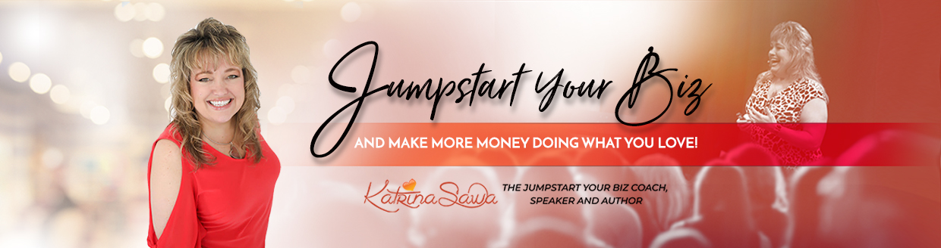

**The 22 Point Sales Page Copy Outline**

**By Katrina Sawa, the Jumpstart Your Biz Coach**

Are you wondering why very few people if any, buy your products, programs, books and services directly from your website?

I’ve looked at thousands and thousands of sales pages and webpages for clients and other entrepreneurs throughout the 19 years I’ve been in business and ***it usually comes down to ONE THING:***

***INEFFECTIVE SALES PAGE COPY***

That’s why your sales pages may not be working well enough... the second thing however is also because:

***YOU ARE NOT SHARING THAT PAGE WITH ENOUGH PEOPLE***

You do have to “market” that page, share it out with hundreds or thousands of folks just to get a couple handfuls to pay attention these days.

Now, I’m not one to sell a ton of my products and programs via my website either but when I do promote them, people do buy. I just focus more on selling via 1on1 conversations instead. That is where I thrive.

But all of us need to have better sales pages, opt in pages, landing pages and better conversion, right?

***So why not make your pages THE BEST THEY CAN BE!?***

Here is an outline that I talked out to my Live Big Mastermind on one of our monthly group calls the other day that I thought I would share with more people so more of you could thrive in YOUR sales too!

**Answer these questions or write copy to fit this outline/template and you will create a good start to a compelling sales page** for either an event, webinar, product, program or service. Use this outline for any of those. Remember, you are writing this to someone that doesn’t yet know you, like you or trust you ideally... others will come but you want to include everything possible anyone would want to know or they may NOT click and buy/signup.

1. Large Headline (Attention Grabbing) - speak directly to the ideal client - could be questions or talking points around the main problem or takeaway/result they’re looking for
2. Add a video too with you getting more personal so they can “feel your energy”
3. Throw in more Questions perhaps to touch on every scenario for your ideal clients
4. Agitating the copy here then, relate to them and how they’re feeling, what they’re thinking and/or what they’ve experienced or done prior and how this is different
5. Talk about why you created this (program/product/event) how you got to creating this - share more about your why/story perhaps too if it makes sense
6. Explain who this is for and Why they should care
7. Invitation to join me…(and who else is in the room)
8. Outline what they will Experience/What they will learn (What’s In It For Them) – several bullets
9. What Bonuses are included
10. Times & Dates or all logistical details
11. Specify if in person or virtual (vs live)
12. Outline the Total Value of all they will get
13. Then share the investment
14. And Justify the cost… talk about where they would spend this money elsewhere, why not here, or how they’ll get a ROI on this
15. Speak to the transformation (i.e., you can make X from the information)
16. Sense of urgency (disappearing bonuses, # of tickets, decide by X, for the first X people)
17. Testimonials (written & video)
18. FAQ’s (cancellation policy, bring a friend, lodging)
19. Full contact info to make it easy for them to reach out if they have other questions
20. Disclaimer for any legalities that you might need to cover your butt on
21. Guarantee, money back guarantees often increase the number of people who buy
22. Possibly put your headshot and bio or more about you somewhere too, maybe the bottom

Now, if you read through all this and think “this is too much information, I don’t need all of this” then I would urge you to rethink that. Unless you’re selling something for a couple hundred bucks or less, you will want all of this on your sales or opt-in page. You have to answer every single question in someone’s head so that when they read through the page, they don’t have any lingering questions. If they have lingering questions they will not buy!



I’m Katrina Sawa... a Speaker, 14x Int’l Best-Selling Author with 22 books and known as the Jumpstart Your Biz Coach...I’ve been a business and marketing coach now since 2002 and I know a lot about a lot when it comes to creating and enjoying a smooth-running, consistent, moneymaking business.

I love motivating, educating and inspiring entrepreneurs on how to jumpstart your business, make more money, tweak and shift what you’re doing right now or how to do things differently so you can be more productive, profitable and impactful. I offer one-on-one coaching, my Live Big Mastermind, live events, virtual trainings, and zoom calls for networking, training and masterminding that anyone can join.

Here is a quick 3.5 min video about me too if you want to know more. <https://youtu.be/ekq74IYIf2w>

Contact me at [katrina@jumpstartyourbiznow.com](mailto:katrina@jumpstartyourbiznow.com) or 916-872-4000.

And if you REALLY want to move quickly in developing a consistent revenue generating business then come chat with me 1on1, sign up at [www.AskKat.biz](http://www.AskKat.biz).

I look forward to serving, educating and inspiring you to jumpstart your business and take it to the next level faster.

