

**USE THIS DOCUMENT TO CREATE YOUR BLURBS SO YOU’RE MORE ORGANIZED & EFFICIENT WHEN ON ZOOM CALLS/EVENTS.**

**______________**

**Zoom Blurbs Template Doc for Chat Room Connecting**

**Model these for your own info and your own offerings and have them ready for whenever you attend or host a zoom networking event! That way you can spend your time paying better attention to WHO IS IN THE ROOM and how you can make connections rather than sitting there typing up these blurbs to share your stuff.**

**______________**

**Basic Info only but put a quick call to action with freebie - you can stack your lines of content so it spaces it nicely in the chat if you want.**

**Katrina Sawa**

**The Jumpstart Your Biz Coach, Speaker & Int’l Best-Selling Author with 11 books**

**916-872-4000** [katrina@jumpstartyourbiznow.com](mailto:katrina@jumpstartyourbiznow.com)

Feel free to go grab a TON of free gifts and trainings from me to help you build and grow your biz here 🡪 <https://www.JumpstartYourBizNow.com/freetrainings>

**INTRODUCTIONS - you might have a couple, depending on the groups you attend and what they usually ask you to share (i.e. where you live, how you serve, etc.) Test it out in the chat as the blurbs can only be so long, you might need to edit it and create two blurbs if too long.**

Hi, I’m Katrina Sawa... speaker, author and biz coach... I love motivating, educating and inspiring entrepreneurs on how to jumpstart their businesses, make more money, tweak and shift what they’re doing right now or how to do things differently so they can be more productive, profitable and impactful. You can grab some free trainings on my website at https://[www.JumpstartYourBizNow.com/freetrainings](http://www.JumpstartYourBizNow.com/freetrainings)

I offer coaching, have a mastermind, live events, virtual trainings, and zoom calls for networking, training and masterminding that you can join. It’s soooo important to say in the conversation like this OFTEN with other highly motivated, amazing entrepreneurs like you to push you, lift you up, hold you accountable and also to find people to collaborate with and even find clients too!

One of the groups that I run is the Int’l Speaker Network. The ISN has 2 monthly zoom calls for networking, masterminding and training, for free, including a facebook group, webinar replays, and opportunities to be a speaker too. Sign up and get the calls on your calendar now, membership is free, plus get a free audio on how to get started speaking and/or apply to speak yourself! https://[www.iSpeakerNetwork.com](http://www.iSpeakerNetwork.com).

***Polka Dot specific intro (intro for a specific group based on reqs):***

Hi ladies! Katrina Sawa here - speaker, Int’l Best-selling author with 11 books and the Jumpstart Your Biz Coach - Worldwide Chapter & Diamond Member - I help entrepreneurs make a lot more money doing what you love. This includes helping you develop and tweak a LOT of things from your online presence, website, social media, all other marketing, being a speaker, author, knowing what your business models are, what you’re selling, how to package and price yourself, developing your confidence to charge more, reach more, do more and learning everything you need to know to jumpstart your business and profits. You can find out all about me plus get a ton of free trainings, my newsletter and more at <https://www.JumpstartYourBizNow.com/freetrainings>. Reach out and connect! [katrina@jumpstartyourbiznow.com](mailto:katrina@jumpstartyourbiznow.com) or 916-872-4000

**Things you might need to say on a call or want to share privately with someone:**

***If you hear someone that you’d love to connect with or want to schedule a call with then you might private message them in the chat this:***

I think we might be able to refer business to each other, I would love to do a connect call with you to learn more and see what’s possible. Here’s my online scheduler if you want to book something: <https://go.oncehub.com/katsguest>

I would love to connect with anyone to brainstorm, share ideas about biz, people looking to collaborate or who need resources for anything business/author/speaker stuff… I have a ton of connections. ;-) [katrina@jumpstartyourmarketing.com](mailto:katrina@jumpstartyourmarketing.com) Or book online at <https://go.oncehub.com/katsguest>

***If the host or someone says, put in the chat things that you might need a referral for or things or people you’re looking for, you could put something like this to engage others:***

I’m excited that I’m seeing SO MANY people that I’ve connected with already… I would love to connect with any of you who

1 - has no idea who I am OR

2 - anyone who is looking to book a speaker around business/marketing/love/money

3 - anyone who could use some support to grow their business and/or write a book OR

4 - anyone who wants to attend more zoom calls for networking to grow their business (I have a list to share!)

5 - anyone who has a podcast and is looking for guests

6 - anyone who wants a website review (sharing your thing)

***If someone mentions wanting speaking gigs for example in their intro or in general then you might put something in the chat like this:***

I love to speak too on anything business, marketing, money, websites, love and more! Here’s my speaker page with videos: <https://jumpstartyourbiznow.com/speaking/>

**Call to actions or offering blurbs (I would keep this to mostly FREE stuff on zoom calls that are not hosted by you, and then if you must sell something or offer a paid thing, I recommend keeping it under $200 if I were you. You can send them to a free ebook, audio, webinar, or program. You can also create a drawing that you might host too like the first example here - usually I do that from speaking opportunities only, not as an attendee.):**

Please go get access to a few different free trainings & *ENTER TO WIN my Jumpstart Your Marketing Course!* https://[www.JumpstartYourBizNow.com](http://www.JumpstartYourBizNow.com)[/EnterToWin](http://www.jumpstartyourbiznow.com/EnterToWin)

Are you ready to HOST YOUR OWN EVENT!? ;-) I would love to help you get that going - live or virtually… I’m really good at doing them AND monetizing them!!! I have a 4-week training all about “Jumpstarting Your Events – In Person or Virtual – How to Build Your Community, Grow Your Influence and Rock Your Profits!” It’s just $197 ad you can go through it at your own pace. Come learn a TON of stuff I know about all types of events, calls, etc. <https://jumpstartyourbiznow.com/jsyevents/>

LAST CHANCE for you to register for my Jumpstart Your Biz live (virtual) event coming up where I help you jumpstart your business and plot out your entire roadmap for a consistent moneymaking business doing what you love. It’s a very interactive business and marketing training. It’s $147 and you get the printed workbook in the mail plus a bunch of other goodies! You also will get the recordings of the whole thing plus 14 additional business/marketing templates you can use to save time AND my Jumpstart Your Networking on Zoom Training as a bonus too (that alone is a $197 value). It’s April 28-30, 2021 and I hope to see you there! Info & Registration at: <https://jumpstartyourbiznow.com/jumpstartyourbizweekend/>

I’m offering a Free Jumpstart Your Biz Training Series right now where we’re talking a lot about how to attracts clients, uplevel your pricing, use the right technology and systems, engage more on social media, get more visibility in your biz and more... go here to get access for free: <https://jumpstartyourbiznow.com/jsybtrainingseries> (a lot of you have asked about effective marketing strategies so I wanted to share)

Learn the business of speaking with my Jumpstart Yourself as a Speaker 6-Week Training. Learn how to design your talk, create your marketing materials and back of the room set up so you LOOK like an expert and professional. Learn how to make offers, what to sell, when to make offers and when not to plus so much more in preparing yourself to become a more sought after speaker AND one who monetizes what you're doing too! Find out more here and get 50% OFF when you use coupon code 500OFF! <https://jumpstartyourbiznow.com/speakertraining/>

OR... go get access to a free speaker audio training to get started somewhere: <http://www.jumpstartspeakertraining.com/>

**Blurbs that others can copy and paste and share for you - when appropriate to make an ask, ask others on the call if they would share out your webinar, call, event, free gift, etc. If they agree, have blurbs available to give them in the chat in general or privately but *make sure they are written in the 3rd person!***

Check out my friend Katrina Sawa’s Jumpstart Your Biz Virtual Workshop that is coming up this April 28-30, 2021. Katrina is a 18+ year biz coach and helps people jumpstart your business and plot out your entire roadmap for a consistent moneymaking business doing what you love. Her event is a very interactive business and marketing training. It ranges from $147-297 and she’s mailing an awesome swag box but there are only 100 seats! Also as a bonus she’s giving access to her 3-part Zoom Networking training too! Go here to sign up now, you’ll be glad you did! <https://jumpstartyourbiznow.com/jumpstartvirtual2021/>

My friend, and seasoned business coach, Katrina Sawa, has some amazing free trainings for small business owners and entrepreneurs to get more clients, do more effective marketing, build a website or for those who want to become authors or speakers... go check out her website and free trainings page for audios, webinars, checklists and more now! You’ll be glad you did! [www.JumpstartYourBizNow.com/freetrainings](http://www.JumpstartYourBizNow.com/freetrainings)

IF ANYONE COULD SHARE THIS, THAT WOULD BE AMAZING!! Thank you in advance, just copy and paste the info below into a new post. xoxo

============

My friend Katrina Sawa runs the Int’l Speaker Network which is a very interactive group of new and seasoned speakers and business owners that 2 monthly webinars and networking meetings on zoom. Anyone can join, it’s FREE and all topics are covered that relate to being a speaker, getting booked, developing your talks, to getting paid from speaking, and even business topics such as developing new online courses, how to close more sales plus a plethera of ways to market and grow your business.  If you’re looking for a community to join to get feedback, advice, share resources and more all about SPEAKING then you want to join the ISN! Info at <https://ispeakernetwork.com/>.

IF ANYONE COULD SHARE THIS, THAT WOULD BE AMAZING!! Thank you in advance, just copy and paste the info below into a new post. xoxo

============

My friend Katrina Sawa is hosting a one-time 3-week program on zoom to help you change up your business and develop, market, sell and run an online course, membership program, online virtual workshop, mastermind or any type of online/virtual training or calls you can SELL to continue working and making money doing what you love. Check out the video and webpage about this asap as it starts THIS THURSDAY - It’s only $197 you guys, come and get something in place THIS WEEK that you can sell and promote right now. See you there! <https://jumpstartyourbiznow.com/jsycourse/>

**BLURB ABOUT WHAT YOU’RE LOOKING FOR:**

Hi everyone, I’m Katrina Sawa, speaker, author and 18 year business coach... I live in the greater Sacramento CA area - I love motivating, educating and inspiring entrepreneurs on how to jumpstart their businesses, make more money, tweak and shift what they’re doing right now or how to do things differently so they can be more productive, profitable and impactful. I do coaching, have masterminds, live events, virtual trainings and a bunch of FREE trainings for entrepreneurs here: [www.JumpstartYourBizNow.com/freetrainings](http://www.JumpstartYourBizNow.com/freetrainings)

I’m looking for connections to or with people who:

* Need help with marketing
* Are trying to create online programs
* Want to become an author
* Want to get more clients from Zoom events
* Want to monetize speaking opportunities
* Are starting up new businesses or shifting, needing a plan/direction

I’d love to do connect calls with anyone who has similar interests or clients where we can potentially refer business to one another. Email me: [katrina@jumpstartyourbiznow.com](mailto:katrina@jumpstartyourbiznow.com)

I’m looking for authors for the 2021, Jumpstart Your ___, Vol IV compilation book

… it’s a collaboration of stories and chapters where each author writes about the topic and expertise that YOU have, so JSY Sales, Mindset, Health, Fitness, Gratitude, Social Media, Mindfulness - whatever you SELL you write about and then use the book as your marketing tool to get them to go to your website. If you know anyone who wants to become an author right now and find an EASY way to make this happen this year, then this could be a good option! Anyone know anyone who might be interested? <https://jumpstartyourbiznow.com/jumpstartcompilation/>

**Group that you run SPECIFIC blurbs - have blurbs ready for the calls YOU RUN also... don’t forget this. You can even take it a step further and give these blurbs to an assistant, client or friend to help you “work the chat” while you’re busy speaking or running the meeting.:**

**Here is the page to find the Int’l Speaker Network recordings, chat notes, place to apply to be a speaker, Facebook group link, etc.: https://**[**www.iSpeakerNetwork.com**](http://www.iSpeakerNetwork.com)

Our Int’l Speaker Network Facebook group is here: <https://www.facebook.com/groups/ispeakernetwork>

**The meetup group for ISN is here (RSVP for events here):** [**https://www.meetup.com/internationalspeakersnetwork**](https://www.meetup.com/internationalspeakersnetwork)

**I hope you found this helpful!! If you would like to connect with me further, have a call or discuss the possibilities for jumpstarting your business, please reach out and/or sign up for a strategy call 1on1 with me at** [**http://askkat.biz/**](http://askkat.biz/)**.**

Katrina Sawa

Award Winning Speaker,

Jumpstart Your Biz Coach &   
International Best-Selling Author with 11 books

916-872-4000  
[katrina@jumpstartyourbiznow.com](mailto:katrina@jumpstartyourbiznow.com)



**Book ME to Speak at Your Next Virtual or In-Person Event!**

[www.JumpstartYourBizNow.com/freetrainings](http://www.JumpstartYourBizNow.com/freetrainings) - Free tips to Jumpstart Your Biz!

[www.iSpeakerNetwork.com](http://www.iSpeakerNetwork.com)  - Free monthly webinars to Jumpstart Your Speaking!

[www.LiveBigEvents.com](http://www.LiveBigEvents.com) - Affordable live annual and virtual events to Jumpstart Your Biz!

[www.JumpstartPublishing.net](http://www.JumpstartPublishing.net) - Affordable, done for you and done with you book publishing services.

PS: Want to JV or have a call about how we could possibly refer to one another? Then email me and I’ll share my online scheduler, I love to collaborate!

PPS: See how valuable THIS TEMPLATE was for YOU? You can create one for what you do and give it out like this also... many people may want it!

**My Next Virtual Business & Marketing Workshop:**

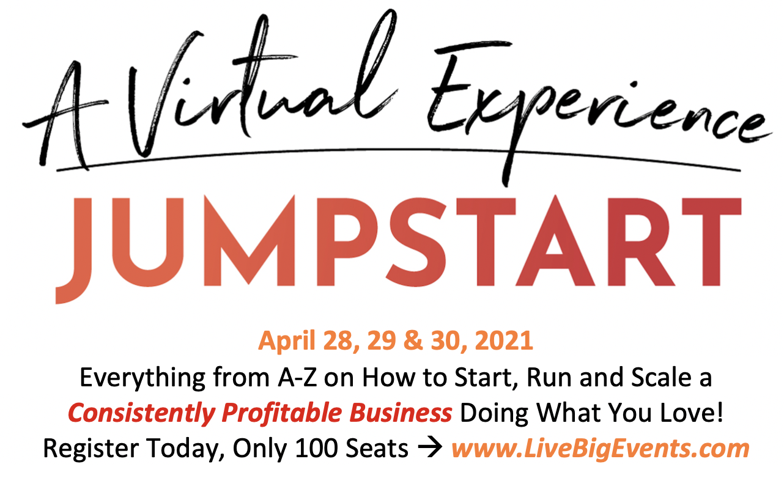

**One of my most requested speaker topics:**

