Thank you for considering booking Kim McLaughlin to speak at your upcoming event.
Kim McLaughlin, M.A. is a dynamic speaker who helps audiences look at food and overeating in a different way. She is an engaging presenter. Audience members leave feeling understood and have steps they can do immediately to change their eating pattern.
Her topics are ideal for a 90 minute keynote presentation however they may also be customized to fit your group, timeframe and topic as needed.
Kim typically makes a small offer in all of her presentations so that those who want more can get it. If you prefer there to be no offers made, she can instead, do a drawing or giveaway to capture contact information of those who are interested.
Thank you,
Kim McLaughlin, M.A.
www.FeedYourSoulUnlimited.com
(916) 847-8053
info@feedyoursoulunlimited.com

Please list Kim as: Kim McLaughlin, M.A.
Feed Your Soul Logo: Kim McLaughlin Headshot:
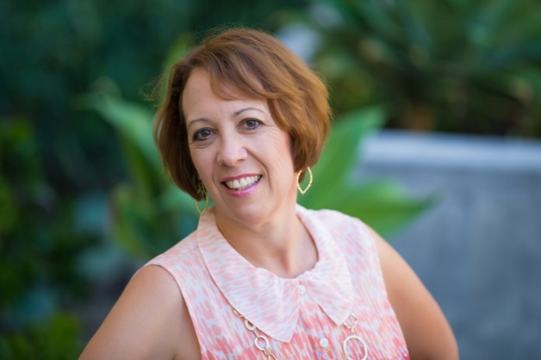

Contact links for Kim online:
Main Website: www.FeedYourSoulUnlimited.com
Facebook: https://www.facebook.com/KimMcLaughlinLMFT/

Speaker Bio
Kim McLaughlin, MA is a licensed psychotherapist and a motivational coach who works with people who suffer from emotional eating, body image issues, self-esteem and binge eating. She is passionate about helping people feed their soul and put food in its proper place as nourishment. Kim has been a speaker for many groups and she enjoys sharing the message that you can look at food differently. You can find out more about Kim plus get access to her monthly free calls and her Free Report: Top Strategies to End Binge Eating at www.FeedYourSoulUnlimited.com

Topic: 3 Steps to End Emotional Eating
How to end emotional eating and feel better about yourself.
Do you find that you eat when you are not hungry? Do you end up eating more than you planned, and then feel afraid you will gain weight? Do you find that you eat for emotional reasons?
You are a smart person and can’t seem to figure out how to stop the battle with food and your weight. You have tried diet after diet, and nothing seems to work for the long haul. It can seem like there is no way out of the cycle of dieting, overeating, and then feeling guilty from gaining weight. A lot of pressure is put on women to look a certain way and often we feel very upset with the way our body looks. This pressure shows up in a way that makes us think we need to diet again to lose weight.
In this presentation you will learn:
- How to identify the emotions that lead you to overeat.
- Determine tools that you can use immediately to stop overeating.
- See how emotional eating is really not about the food.
Join Kim McLaughlin in an engaging discussion about overeating, food, weight, and how to begin feeling better about yourself. You will come away with at least one tool you can use immediately to help you look at food and your body differently.

